**Setting Up Your Development Environment**

**Objective:** Install essential development tools and configure Git to begin software development projects.

**Instructions:** This assignment will walk you through the process of setting up your development environment by installing Visual Studio Code, Python, and GitBash, and by setting up a GitHub account. You will also install several useful extensions in Visual Studio Code to enhance your coding experience.

**Part 1: Installation of Tools**

**Visual Studio Code Installation**

1. Download VS Code from Visual Studio Code Official Website.

2. Follow the installation instructions on the website.

3. **Submission:** Take a screenshot of the VS Code running on your computer.

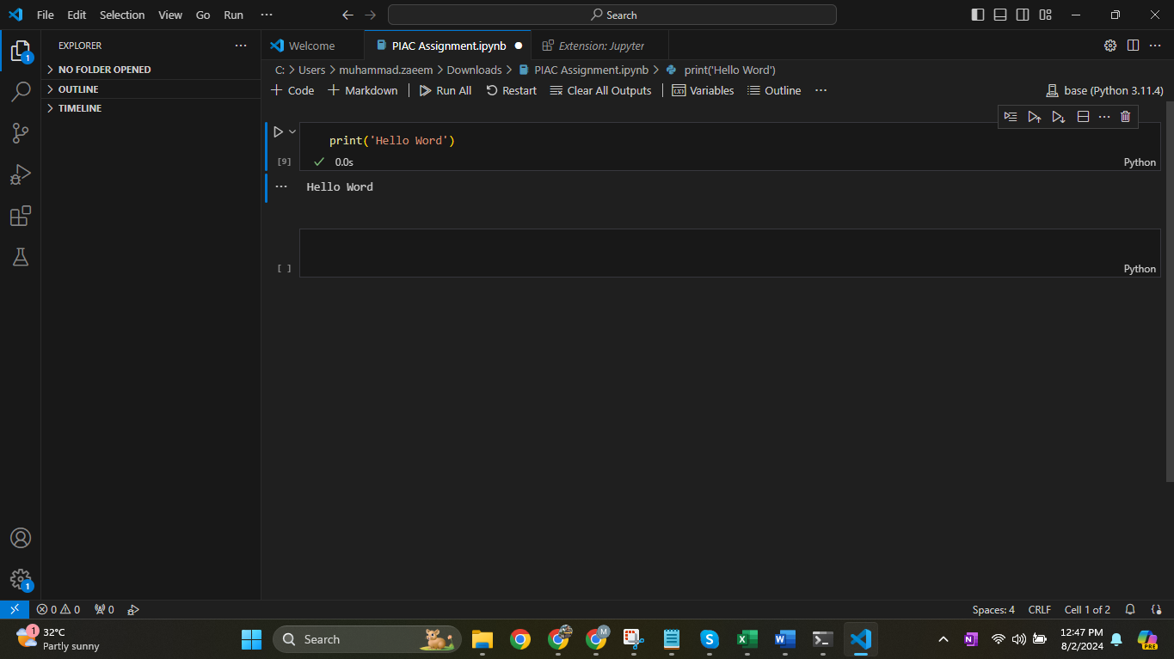

**Python Installation**

1. Download Python from Python Official Downloads.

2. During installation, ensure to select the checkboxes:

○ Add Python to PATH

○ Install launcher for all users (recommended)

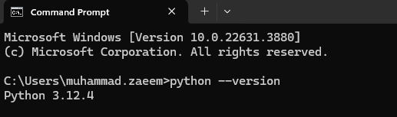To verify the installation, open your terminal or command prompt and run: python --version

3. **Submission:** Take a screenshot of the terminal showing the Python version.

**GitBash Installation**

1. Download GitBash from GitBash Downloads.

2. Follow the installation instructions provided.

To verify installation, open GitBash and type:

git --version

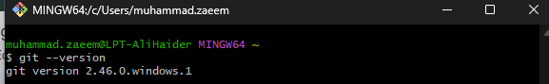

3. **Submission:** Take a screenshot of the GitBash window showing the Git version.

**Part 2: Setting Up GitHub Account**

1. Create a GitHub Account at GitHub.

Configure your Git account with your name and email by running these commands in GitBash:

git config --global user.name "Your Name"

git config --global user.email "youremail@example.com" Check your current configuration with:

git config --list

2. **Submission:** Take a screenshot of your Git configuration settings in GitBash.

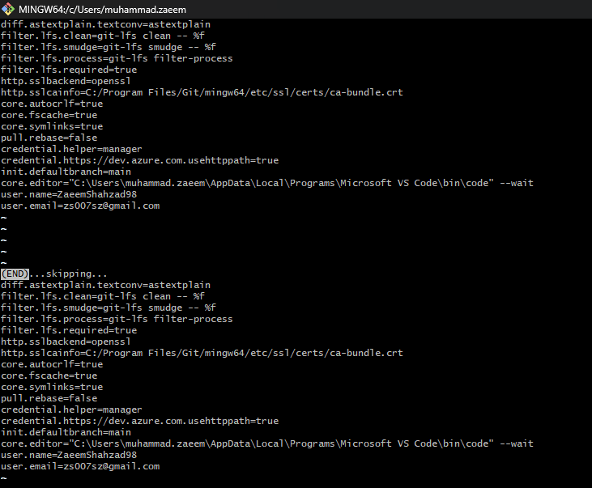

**Part 3: VS Code Extensions**

Install the following extensions in Visual Studio Code by searching them in the Extensions view (Ctrl+Shift+X):

● Material Icon Theme

● GitLens – Git supercharged

● Prettier – Code formatter

● Python

● Python debugger

● Jupyter

● Code Spell Checker

**Submission:** Take a screenshot of your VS Code showing the installed extensions.

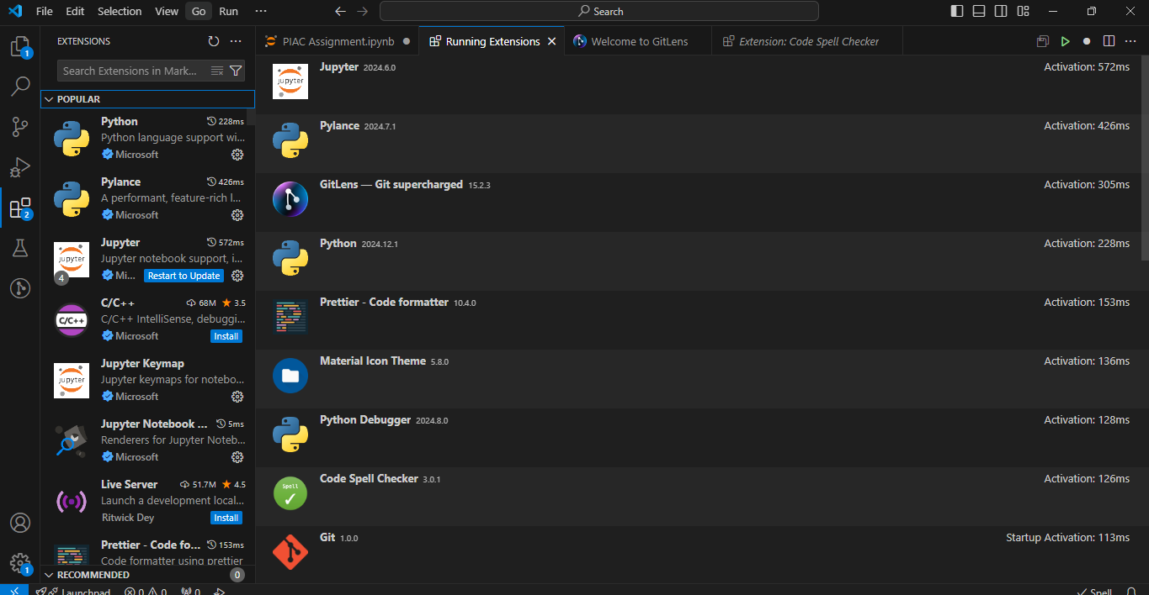

**How to Submit:** Upload the screenshots to Google Classroom in the respective assignment section. Ensure each screenshot is clearly labeled according to the part of the assignment it corresponds to.